Chapter 8, Problem 65.

Determine the differential equation for the op amp circuit in Fig. 8.110.
If v₁(0⁺) = 2 V and v₂(0⁺) = 0 V, find v_{o} for t > 0. Let R = 100 kΩ and C = 1 μF.

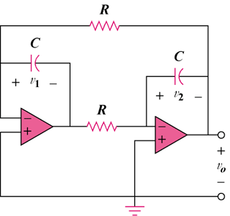

Figure 8.110

